EOS SHARED BY ALL

Integrating EOS into your company requires a level of mastery on the leadership team, as well as a clear plan and commitment to make it “stick.” Since each company’s culture is different, there is no specific formula to take EOS companywide – only general guidelines. As Gino Wickman says, each company is a “snowflake.” With that in mind, here is a checklist and helpful ideas used by successful EOS companies:

Y N
The Leadership Team has completed the 5 Foundational Tools  
and demonstrated a level of mastery with EOS:
- VTO
- Accountability Chart
- Rock Sheet
- Level 10 Meetings
- Scorecard
EOS launched companywide at an All Employee Meeting:  
- The CEO gives “The Speech”
- Introduce EOS Model and why it was chosen
- Introduce the VTO and hand out a copy
  - Talk about “Core Values”
  - Review remaining sections of the VTO
- Review the EOS Proven Process
- Describe “Next Steps” of the roll out/see managers with questions
- Conclude by summarizing the talk/asking if there are any questions
- Hand out the book, TRACTION, to all employees
- Encourage people to get on the same page by reading the book
Mid-Managers have read TRACTION and demonstrated a  
level of comfort with the EOS system:
- Determine a Leadership Team mentor for each Mid-Manager
- Offer a 90 Minute Meeting to get everyone on the same page
- Define Mid-Manager role with EOS and instill accountability
- Provide the necessary tools, resources, training
The Leadership Team integrates key EOS tools companywide:  
- Conduct “Quarterly Conversations”
- “What’s working/not working?”
- The 5-5-5 (5 Values, 5 Roles, 5 Rocks)
- Conduct “State of the Company” meetings after each quarterly.
- Roll out GWC, People Analyzer, 1-Page Performance Review
- Empower HR function: Hire, fire, review, reward, recognize, measure results
- Conduct “Clear the Air” or “Personal Issues Solving” meetings to resolve conflict
- Roll out remaining EOS Tools – Delegate & Elevate, LMA, StrengthsFinders, etc.

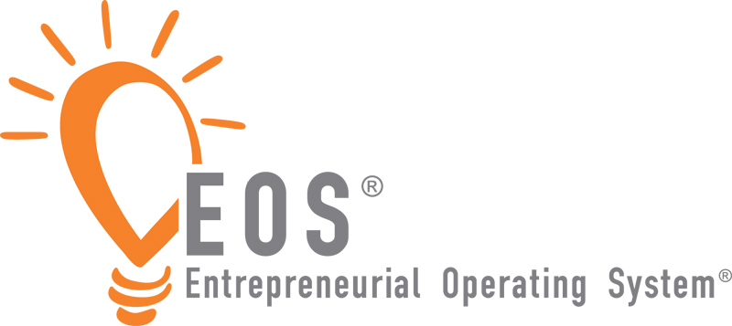
Mid-Managers are running on EOS:  
- Accountability Chart by department
- Quarterly Rock Sheet by department, 3-5
- Weekly Level 10 Meetings rated
- Measurables by department, 1-3
- All reinforcing company 10-YR Target, 3-YR
Picture, 1-Year Plan and Quarterly Rocks

The Leadership Team sustains EOS companywide, with  
the goal of operating at 100% in all 6 components:
- VTO “Shared by All”
- All the Right People are in the Right Seats
- Scorecard of weekly metrics mastered
- Everyone has at least one measurable
- Issues documented and IDS’ed weekly and quarterly
- Core Processes documented and followed by all
- Meeting Pulse continues – L10s, Quarterlies, Annuals
- EOS reinforced at All Employee Meetings
- Living the values “stories”
- High-5s
- Results
- Quarterly Conversations and Annual Employee Reviews in place
- Mid-Managers empowered with tools, resources, training
- EOS integrated in hiring, firing, reviewing, rewarding, recognizing
- Financial metrics monitored regularly monthly or quarterly

Company regularly measures and reports results of EOS.  
Menu of suggested measures:
- Annual Organizational Check-Up
- L10 Meeting ratings 8+
- Team health/cohesion
- Employee satisfaction, retention
- Employee productivity, quality
- Better quality recruiting candidates
- Revenue, profit, company value
- Happy existing customers, retention, growth
- Increase in new “ideal” customers

Company uses the 3L Model of sustainability:  
- Learning: Training, teambuilding, online learning, workshops,
mentoring, coaching
- Leveraging: Hiring, firing, reviewing, rewarding, recognizing,
measuring, reporting, celebrating
- Leading: Leadership Team accountability, “EOS Champions,”
strong Integrator, Mid-Manager accountability, communications

